Data Technician
Workbook
Week 3
Databases and SQL

Name: Cisca Human
Course Date: 18 May 2026
Table of contents
Day 1: Task 1 3
Day 1: Task 2 6
Day 2: Task 1 8
Day 3: Task 1 11
Day 3: Task 2 13
Day 4: Task 1: SQL Practical 15
Additional Resources 19
Additional Information 19
Course Notes 20

Day 1: Task 1

Scenario-Based SQL Activity: Designing a Normalised Database
Business Scenario
You have been hired as a junior data technician for a small training company called SkillUp Academy.
The company currently stores all its data in a single spreadsheet, which is causing:
- Duplicate information
- Data inconsistencies
- Difficulty updating records
Your task is to design a simple relational database that organises this data more effectively.
Task 1: Database Purpose
Describe the purpose of the database in your own words. Include:
- What the database will be used for
- Who will use it
- What type of data it will store
✍️ Write in full sentences.
The purpose of the database is to store all the course, student, teacher information the Training company needs to run an efficient service, so that data can be trusted, and stored with integrity.
The users of the database will be everyone in the company, for example, finding out what courses are the most attended, which teachers get the highest student reviews, and the students enrolled in what courses. For students, the database will be helpful, as they might look up exam dates, course dates, time tables etc.
The type of data that will be stored can include:
Courses available to be taught with relevant information e.g. Course code, name, level,
Teachers, with their relevant data, e.g. name, contact details, subjects taught, availability
Students and their relevant data, for example, name, contact, student no, address, courses enrolled, payment information
Enrolments, containing student no, course code, start date, progress

Part 2: Identify Tables and Columns
Task 2: Identify Tables
From the scenario, identify at least four tables that should be created.
For each table:
- Give the table name
- List the columns
- Identify the primary key
✍️ You may present your answer as a list or table.

Courses: Course Code (PK), Course name, Level, Duration
Students: Student ID (PK), Student Name, Student Address, Contact No, Student Photo
Teachers: Teacher ID (PK), Teacher Name, Teacher Address, Contact No, Teacher Photo
Teachers-Courses: [Teacher Id (FK), Course Code (FK)], Available from date, Available To date: Composite key to see what courses each teacher can teach, and when they will be available. (Useful for scheduling)
Enrolments:
Enrolment ID (PK), Student ID (FK), Course code (FK), Teacher ID (FK), Paid, Start Date, Student Review

Part 3: Define Relationships Between Tables
Task 3: Table Relationships
Explain how your tables are connected.
You must:
- Identify one-to-many relationships
- Explain which columns are used as foreign keys
- Explain why these relationships are needed
Courses Course Code (PK)
1:M with Enrolments
Students: Student ID (PK)
1:M with Enrolments
Teachers: Teacher ID (PK)
1:M with Enrolments (Assuming every enrolment will only have one teacher per course)
M:M with Courses
Teachers-Courses: [Teacher Id (FK), Course Code (FK)] Composite key
M:M with Teachers
M:M with Courses
Enrolments: Enrolment ID (PK), Student ID (FK), Course code (FK), Teacher ID (FK)
1:1 with student + Teacher + Course

Part 4: Reflection (Optional / Stretch)
Task 5: Reflection
Answer the following:
- What problems does this database design solve?
- What issues might occur if all data stayed in one table?
It avoids data redundancy, improve data integrity, and will speed up queries. For example, knowing what teacher is available in March to teach English will need access to a much smaller subset of the data.

Keeping data in one table makes it more difficult to validate the data correctly, as relationships in itself can establish data integrity. For each enrolment, all information will be duplicated, which is not efficient use of storage capacity. Database queries will take much longer, as much more information has to be processed for each query.

Day 1: Task 2

Choosing the Right Type of Database
Business Scenario
SkillUp Academy is planning to expand its systems.
In addition to structured course and learner data, the company now wants to store:
- Website click data
- User activity logs
- Feedback comments from learners
- Uploaded documents
They are unsure whether a relational database or a non-relational database would be more suitable for this data.
You have been asked to help explain the options.

Task 1: Compare Database Types
In your own words, explain the difference between:
- A relational database
- A non-relational (NoSQL) database
Your answer should include:
- How data is stored
- How structured the data is
- An example use case for each
✍️ Write in clear, simple language.

A relational database organises data into pre-defined, rigid structures that resembles different organisational entities. Data is stored in tables consisting of rows and columns. A table is used to store for example student information, where each row represents the student record, and each column an attribute about the student, for example, name, DOB, etc.
Relationships between tables are defined through unique identifiers that is stored for each record. To modify/Create/Delete a record, the structure is enforced to maintain data integrity.
Example: SkillUpAcademy’s student records, their course enrolments and payment plans is a good applicatiion for RDBMS

A non-relational database is much more fluid and data of different types and structures is stored in whatever format is appropriate at the time Data is not stored in traditional tables. The most common method is to use JSON files, which can best be described as organised text lists. Simple key-value pairs, wide-column stores and graphs are other ways of storing data in a non-RDBMS.
Because data is completely or semi-unstructured, no blueprint is required or enforced when creating or deleting data. This format is flexible and is able to scale as the data grows.

For example: Keeping track of user activity logs and website click data which is what the academy now needs.

Task 2: Identify Suitable Data for a Non-Relational Database
From the scenario above, identify two types of data that would be better stored in a non-relational database.
Examples may include:
- User activity logs
- Feedback text
- Website events
For each type of data:
- State what the data is
- Explain why a non-relational database is suitable
✍️ Focus on flexibility, structure, and data format.
1. User activity logs:
What the data is
Time-stamped records of the actions a student takes when visiting the academy’s website, e.g. logging in, what links were clicked on, what video was watched etc.

Why a non-relational database is suitable:
Website activity generate different types of data, e.g. when pausing a video, the last seen timestamp of the video needs to be logged, and when a quiz is completed, a score must be logged. The inflexibility of a RDBMS will not cope with the vast amount of data generated, neither with the different types of record structures.
Data format used would typically be JSON documents or key-value pairs in real-time. Without a strict blueprint that has to be strictly enforced every time a record is created, modified, or deleted, the non-RDBMS approach is must faster too.

2. Feedback comments:
Text data collected when learners e.g. leave reviews or write comments about the courses.
A non-relational database is suitable because comments are unstructured, can be of any length, has no predictable format, and will be cumbersome to force into a traditional row/column storage method.

Task 3: Justify Your Choice
Explain why this data would not be ideal for a traditional relational database.
Consider:
- Data structure
- Frequency of changes
- Volume of data
✍️ Use plain English — no advanced terminology required.
Traditional RDBMS requires a predefined blueprint for how the data will be stored. In both these cases – website activity log and feedback – the format, length, frequency of change, and volume of data is completely unpredictable, which is not something a RDBMS is designed for.
There is no structure to enforce, and to try to do so, would result in many empty columns per record, duplications, or for some records the columns would be larger than expected.
Having to make sense of these records will probably be beyond the capacity of a traditional database query language.

Day 2: Task 1
You are a junior data analyst at Northwind Traders. Your manager has assigned you a series of real-world business tasks. For each scenario:
- Write an SQL query to solve the request. Write an SQL query to solve the request.
- Run the query in MySQL Workbench using the Northwind database.
- Paste your query in the box below each question as evidence of completion.

1.📘 Retrieve Full Customer Data
Your manager has asked you to export the full list of all customer details into a report.
➡️ Write a SQL query to retrieve all columns from the Customers table.
select * from customers;

2.📘 Customer Names and Cities for Marketing
A marketing analyst is targeting a campaign based on customer names and their cities.
➡️ Write a SQL query to retrieve only the CustomerName and City columns from the Customers table.
select CustomerName, City from customers;

3. 📘 Unique Cities for Delivery Network Expansion
The logistics team wants to know all the different cities where customers are located (no duplicates).
➡️ Write a SQL query to retrieve distinct values from the City column in the Customers table.
select distinct City from customers;

4.📘 High-Value Products Report
The product manager wants to analyse products priced over £50.
➡️ Write a SQL query to retrieve all columns from the Products table where the Price is greater than 50.
select * from products where price > 50;

5.📘 International Customers Targeting (USA & UK)
The marketing team is preparing campaigns for customers in the USA and UK.
➡️ Write a SQL query to retrieve all columns from the Customers table where the Country is either 'USA' or 'UK'.
select * from customers where country in ('UK', 'USA');

6.📘 Recent Orders Report
Your team needs to analyze the latest orders.
➡️ Write a SQL query to retrieve all columns from the Orders table, sorted by OrderDate in descending order.
select *
from orders
order by OrderDate desc;

7.📘 Mid-Range Products Listing
You are preparing a product list for items priced between £20 and £50.
➡️ Write a SQL query to retrieve all columns from the Products table where the Price is between 20 and 50, ordered by descending Price.
select * from products
where Price between 20 and 50
order by Price DESC;

8.📘 Local Marketing in the US (Portland & Kirkland)
You’re focusing on customers from Portland and Kirkland in the USA.
➡️ Write a SQL query to retrieve all columns from the Customers table where the Country is 'USA' and City is either 'Portland' or 'Kirkland', ordered by ascending CustomerName.
select *
from customers
where country = 'USA'
and city in ('Portland','Kirkland')
order by CustomerName;

9. 📘 Customers from the UK or London
Prepare a list for promotional emails targeting customers from the UK or those based in London.
➡️ Write a SQL query to retrieve all columns from the Customers table where the Country is 'UK' or City is 'London', ordered by descending CustomerName.
select *
from customers
where country = 'UK'
OR city = 'London'
order by CustomerName;

10.📘 Product Inventory for Selected Categories
The inventory team needs products from Category 1 or 2, sorted alphabetically.
➡️ Write a SQL query to retrieve all columns from the Products table where the CategoryID is 1 or 2, ordered by ascending ProductName.
select *
from products
where CategoryID in (1,2)
order by ProductName;

Day 3: Task 1
Scenario-Based Activity: Understanding SQL JOINs
Business Scenario
SkillUp Academy stores its data across several related tables, such as:
- Learners
- Courses
- Trainers
- Enrolments
To create reports (for example, seeing which learners are enrolled on which courses), the data team needs to combine data from multiple tables.
Different types of SQL JOINs are used depending on what information is needed.

Task 1: Explain JOIN Types (Plain English)
For each JOIN type below:
- Explain what the JOIN does in simple terms
- Explain when it would be used in a real scenario
You do not need to write SQL code unless instructed.
JOIN Types to Explain
- Inner Join
- Left Join
- Right Join
- Full Join
- Cross Join
✍️ Use short, clear explanations.
Inner Join: Tables are joined and only matching records are returned.
Example: To find the most popular courses for this year, the Enrolments table will linked with the Courses table, and only enrolment records that have a matching course in the Courses table will be counted.

Left join: Two tables are joined. The table selected first, is considered the left table. All records will be returned from the left table. Non-matching records for the right table will be displayed as null.
Example: List all courses, including those for which there was no enrolments. Use the Courses table as the left table, and enrolments as the right.

Right join: As for left join, but the table selected second, is considered the right table, and all records from that table will be returned, regardless if there was a match for the left table. The left table will display null records in the case of a non-match.
Example: Join enrolments and trainers to see the trainers who are allocated this semester. If trainers are considered the ‘Right’ table, the query will also return trainers for whom there are no enrolments.
Full join: Return matching and non-matching records from both tables of the join.
Example: A full join of Trainers and enrolments will return all records where trainers are matched to an enrolment, enrolments without trainers, and trainers without enrolments.
(Assuming trainers are allocated per enrolment, and not per course)

Cross join: All possible combinations of two tables are returned. No join condition is required
Example: SkillUp Academy might introduce a levels table that has to be considered for each course. A Cross join between courses and levels, will return all the possible combination of course and level.

Task 2: Match JOINs to Data Scenarios
Below are example reporting needs at SkillUp Academy.
For each one:
- Identify which JOIN type would be most suitable
- Explain why
Example Scenarios
- Viewing only learners who are enrolled on a course
- Listing all courses, including those with no enrolments yet
- Showing all learners and all courses, even if they are not linked
- Creating all possible combinations of learners and courses for planning
- Comparing learners to other learners (e.g. same course, same city)
- Viewing enrolments even if some related data is missing
✍️ Explain your reasoning in plain English.
- Inner join between learners and enrolments, as they are not interested in learners who are not enrolled.
- Left join courses with enrolments, so all courses are listed, and where there are no enrolments for a course, the enrolment columns will display NULL values in the query result.
- Full join, as all learners and all courses, are required. Learners without a match
- Cross join, as all possible combinations for learners and courses will be returned (which might be a very large result set)
- Inner join between learners and enrolments, or possible left join where learners is the left table, so it can also return data on learners not enrolled.
- Left join, with enrolments the left table, so all enrolments are listed, even if there is no trainer assigned, for example.

Day 3: Task 2
You are a junior data analyst at Northwind Traders. Your manager has assigned you a series of real-world business tasks. For each scenario:
- Write an SQL query to solve the request. Write an SQL query to solve the request.
- Run the query in MySQL Workbench using the Northwind database.
- Paste your query in the box below each question as evidence of completion.

1.📘 Linking Products to Suppliers
Management wants to know which supplier provides each product in the inventory.
➡️ Write a SQL query to find the supplier of each product.
select p.productID, p.ProductName, s.SupplierName
from products as p
join suppliers as s
on p.supplierId = s.supplierId;

2. 📘 Classifying Products by Category
The category manager is reviewing how products are organized.
➡️ Write a SQL query to find the category of each product.
-- Write a SQL query to find the category of each product.
select p.productID, p.ProductName, c.CategoryName
from products as p
join categories as c
on p.CategoryID = c.CategoryID
order by c.categoryName, ProductName;

3.📘 Category-Specific Product Report: Meat/Poultry
The food department wants to view all items in the Meat/Poultry category.
➡️ Write a SQL query to retrieve all products belonging to the Meat/Poultry category.
select p.productID, p.ProductName, c.CategoryName
from products as p
join categories as c
on p.CategoryID = c.CategoryID
where c.CategoryName like 'Meat%'
order by c.categoryName, ProductName;

4.📘 Complete Order Overview
The business team wants to see a detailed order list with customer and employee information.
➡️ Write a SQL query to retrieve the Order ID, Order Date, Customer Name, and Employee Name for all orders.
-- Write a SQL query to retrieve the Order ID, Order Date, Customer Name, and Employee Name for all orders.
select o.orderId, o.OrderDate, c.CustomerName, concat_ws(', ', e.FirstName, e.LastName) as EmployeeName
from orders as o
join customers as c on o.customerID = c.customerID
join employees as e on o.employeeID = e.employeeID
order by employeeName;

5.📘 Supply Chain Overview Report
Your manager wants to see the product name, its category, and the name of its supplier all in one report.
➡️ Write a SQL query to retrieve the Product Name, Category Name, and Supplier Name for all products.
-- Write a SQL query to retrieve the Product Name, Category Name, and Supplier Name for all products.
select p.productID, p.ProductName, c.CategoryName, s.SupplierName
from products as p
join categories as c on p.CategoryID = c.CategoryID
join suppliers as s on p.SupplierId = s.SupplierId;

6.📘 Yearly Order Summary – 1996
The team is auditing customer orders made in 1996.
➡️ Write a SQL query to create a report for all the orders of 1996 and their customers.
select o.orderId, o.OrderDate, c.CustomerName
from orders as o
join customers as c on o.customerID = c.customerID
where o.OrderDate between '1996-01-01' and '1996-12-31'
order by O.orderDate;

7.📘 Product Count by Category
The product team wants to know how many products exist under each category.
➡️ Write a SQL query to retrieve all categories along with the number of products in each category.
select c.CategoryName, count(p.productID) as NoOfProducts
from products as p
join categories as c on p.CategoryID = c.CategoryID
group by c.CategoryName;

8.📘 Sales Volume Breakdown
The sales department wants to analyze how much of each product was ordered and at what price.
➡️ Write a SQL query to retrieve all products with their prices and the quantity ordered for each product.
select p.ProductId, p.productName, p.Price, sum(od.Quantity) as TotalProductQty
from products as p
join order_details as od on p.productId = od.ProductId
group by p.productId
order by TotalProductQty DESC, p.ProductName;

Day 4: Task 1: SQL Practical

You are working as a junior data analyst for an international research organization analysing countries, cities, and languages from around the world. Your job is to write and run SQL queries that provide useful global insights.
For each task:
- Write the appropriate SQL query to meet the scenario's objective.
- Run your query using MySQL Workbench and the world database.
- Take a screenshot that clearly shows both your SQL code and the result table.
- Paste the screenshot in the box provided for each question as evidence of completion.
Setting up the database:

- Download world_db here
- Follow each step to create your database here
- Create Schema Design Diagram. How to create Schema Design.webm

- Count Cities in USA: Scenario: You've been tasked with conducting a demographic analysis of cities in the United States. Your first step is to determine the total number of cities within the country to provide a baseline for further analysis.

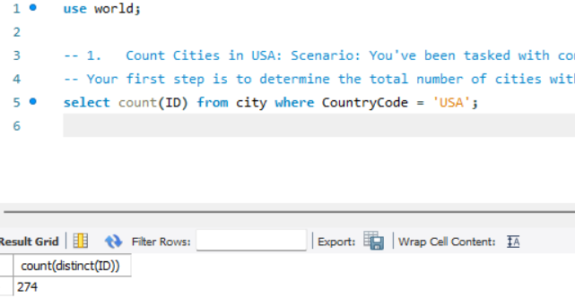

- Country with Highest Life Expectancy: Scenario: As part of a global health initiative, you've been assigned to identify the country with the highest life expectancy. This information will be crucial for prioritising healthcare resources and interventions.

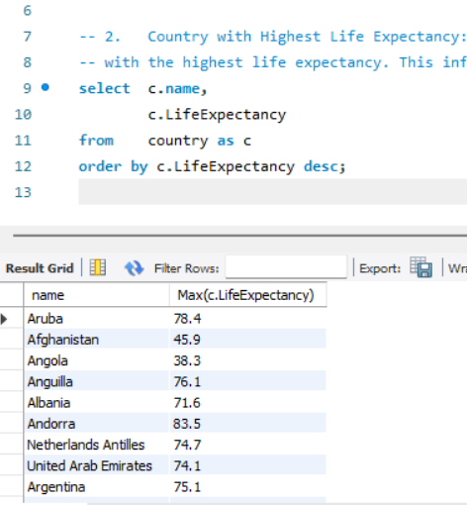

- "New Year Promotion: Featuring Cities with 'New : Scenario: In anticipation of the upcoming New Year, your travel agency is gearing up for a special promotion featuring cities with names including the word 'New'. You're tasked with swiftly compiling a list of all cities from around the world. This curated selection will be essential in creating promotional materials and enticing travellers with exciting destinations to kick off the New Year in style.
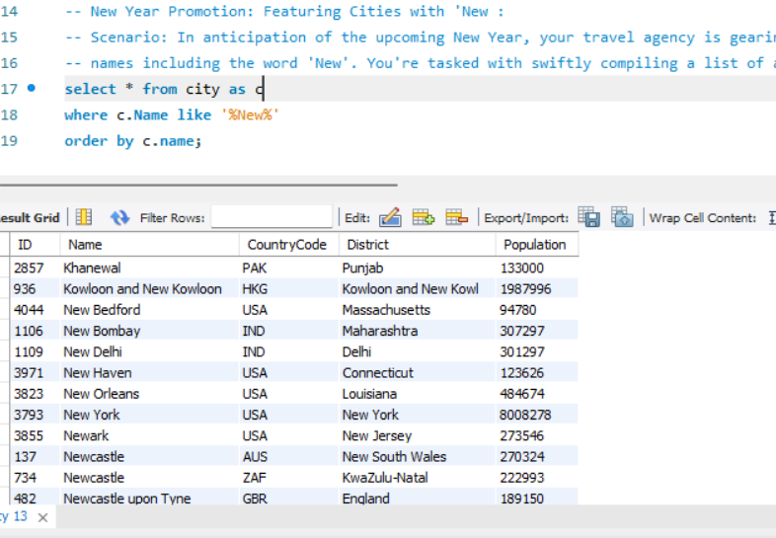

- Display Columns with Limit (First 10 Rows): Scenario: You're tasked with providing a brief overview of the most populous cities in the world. To keep the report concise, you're instructed to list only the first 10 cities by population from the database.
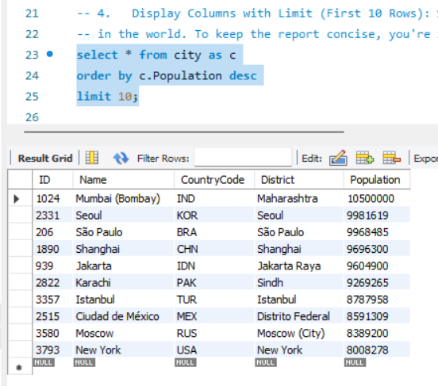

- Cities with Population Larger than 2,000,000: Scenario: A real estate developer is interested in cities with substantial population sizes for potential investment opportunities. You're tasked with identifying cities from the database with populations exceeding 2 million to focus their research efforts.

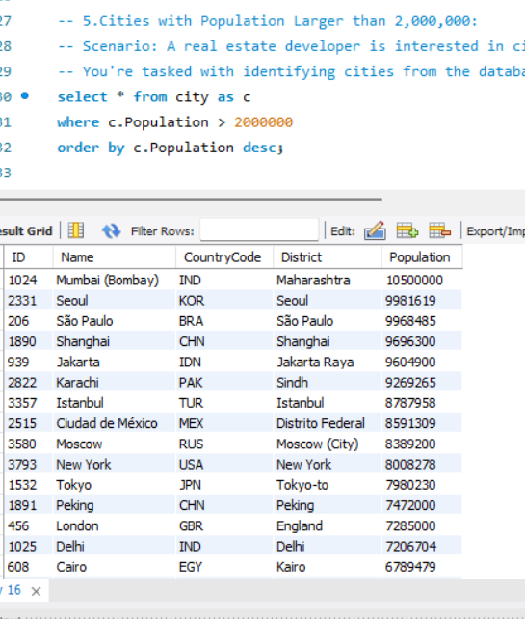

- Cities Beginning with 'Be' Prefix: Scenario: A travel blogger is planning a series of articles featuring cities with unique names. You're tasked with compiling a list of cities from the database that start with the prefix 'Be' to assist in the blogger's content creation process.
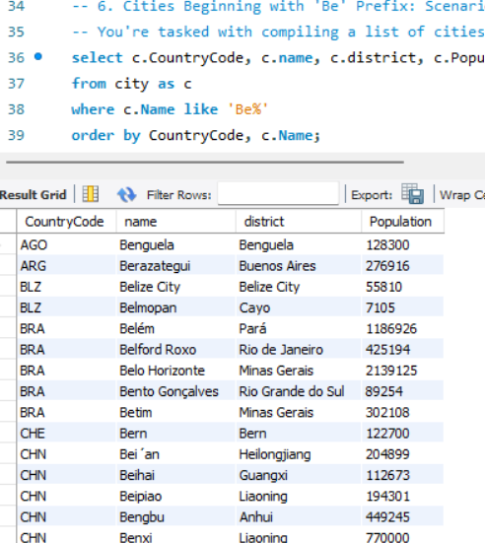

- Cities with Population Between 500,000-1,000,000: Scenario: An urban planning committee needs to identify mid-sized cities suitable for infrastructure development projects. You're tasked with identifying cities with populations ranging between 500,000 and 1 million to inform their decision-making process.
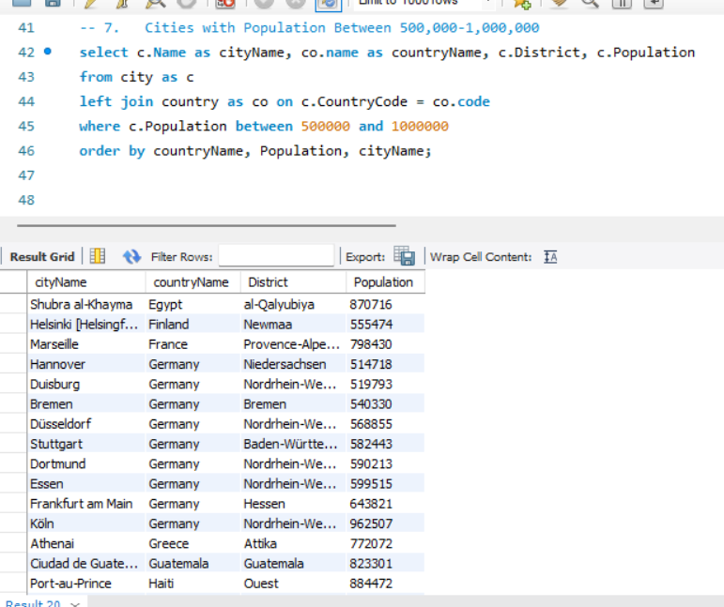

- Display Cities Sorted by Name in Ascending Order: Scenario: A geography teacher is preparing a lesson on alphabetical order using city names. You're tasked with providing a sorted list of cities from the database in ascending order by name to support the lesson plan.
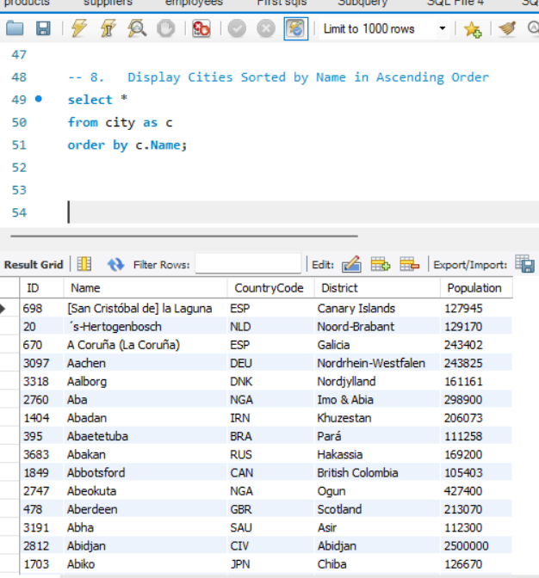

- Most Populated City: Scenario: A real estate investment firm is interested in cities with significant population densities for potential development projects. You're tasked with identifying the most populated city from the database to guide their investment decisions and strategic planning.
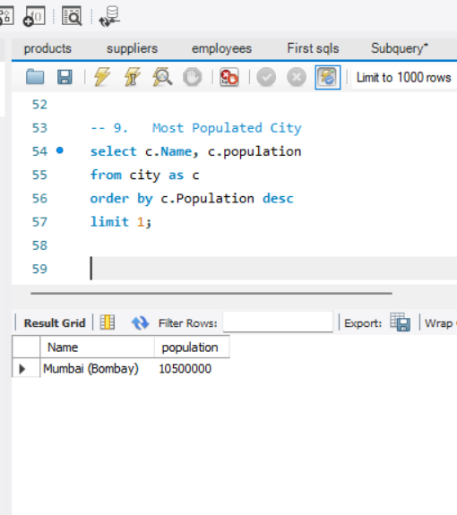

- City Name Frequency Analysis: Supporting Geography Education Scenario: In a geography class, students are learning about the distribution of city names around the world. The teacher, in preparation for a lesson on city name frequencies, wants to provide students with a list of unique city names sorted alphabetically, along with their respective counts of occurrences in the database. You're tasked with this sorted list to support the geography teacher.
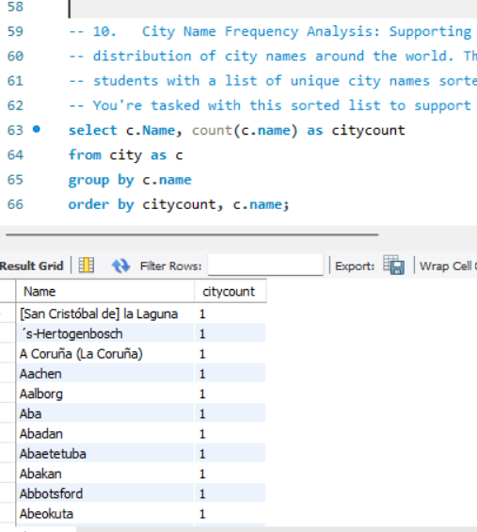

- City with the Lowest Population: Scenario: A census bureau is conducting an analysis of urban population distribution. You're tasked with identifying the city with the lowest population from the database to provide a comprehensive overview of demographic trends.
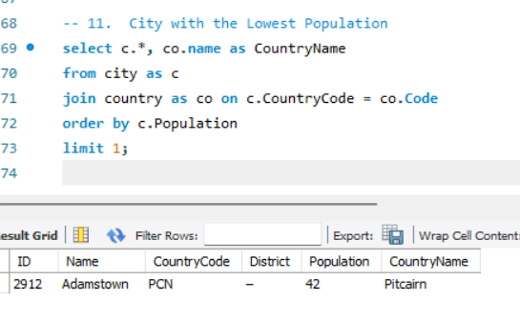

- Country with Largest Population: Scenario: A global economic research institute requires data on countries with the largest populations for a comprehensive analysis. You're tasked with identifying the country with the highest population from the database to provide valuable insights into demographic trends.
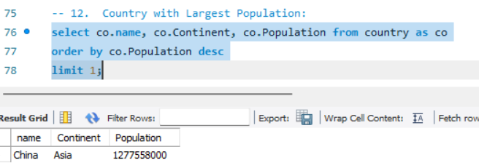

- Capital of Spain: Scenario: A travel agency is organising tours across Europe and needs accurate information on capital cities. You're tasked with identifying the capital of Spain from the database to ensure itinerary accuracy and provide travellers with essential destination information.
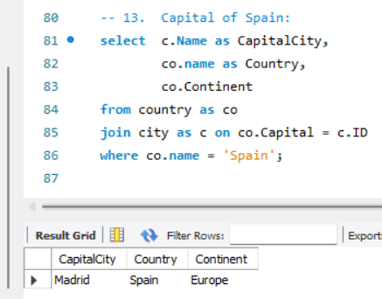

- Cities in Europe: Scenario: A European cultural exchange program is seeking to connect students with cities across the continent. You're tasked with compiling a list of cities located in Europe from the database to facilitate program planning and student engagement.
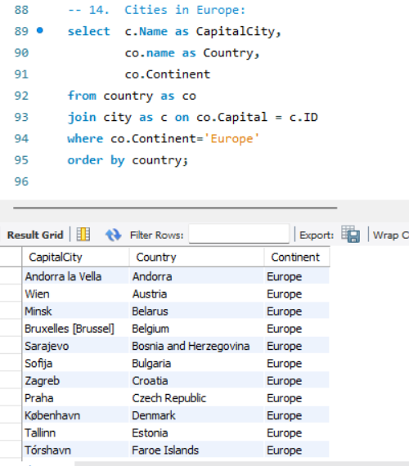

- Average Population by Country: Scenario: A demographic research team is conducting a comparative analysis of population distributions across countries. You're tasked with calculating the average population for each country from the database to provide valuable insights into global population trends.
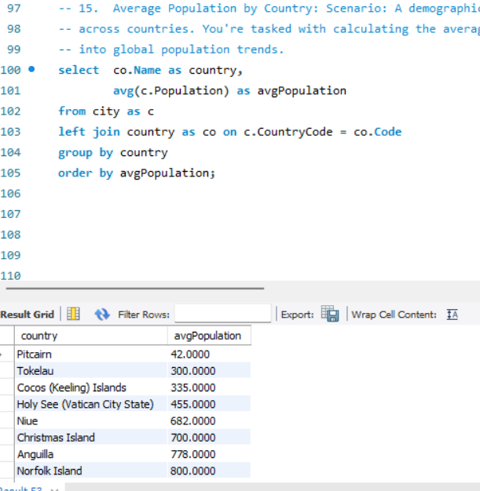

- Capital Cities Population Comparison: Scenario: A statistical analysis firm is examining population distributions between capital cities worldwide. You're tasked with comparing the populations of capital cities from different countries to identify trends and patterns in urban demographics.
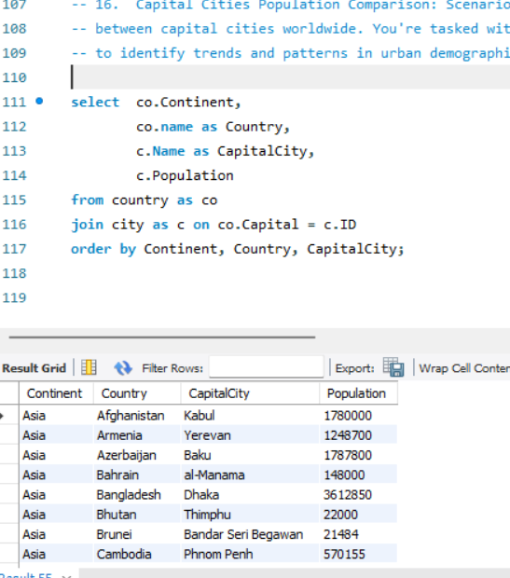

- Countries with Low Population Density: Scenario: An agricultural research institute is studying countries with low population densities for potential agricultural development projects. You're tasked with identifying countries with sparse populations from the database to support the institute's research efforts.
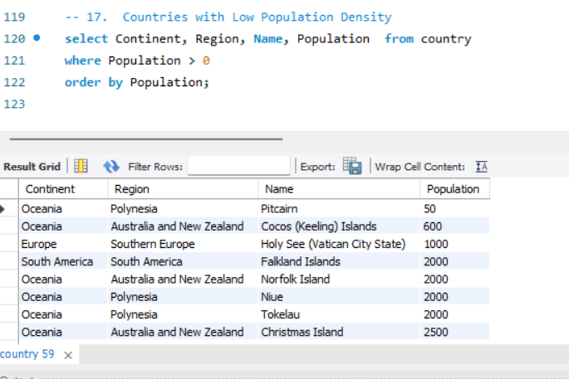

- Display Columns with Limit (Rows 31-40): Scenario: A market research firm requires detailed information on cities beyond the top rankings for a comprehensive analysis. You're tasked with providing data on cities ranked between 31st and 40th by population to ensure a thorough understanding of urban demographics.
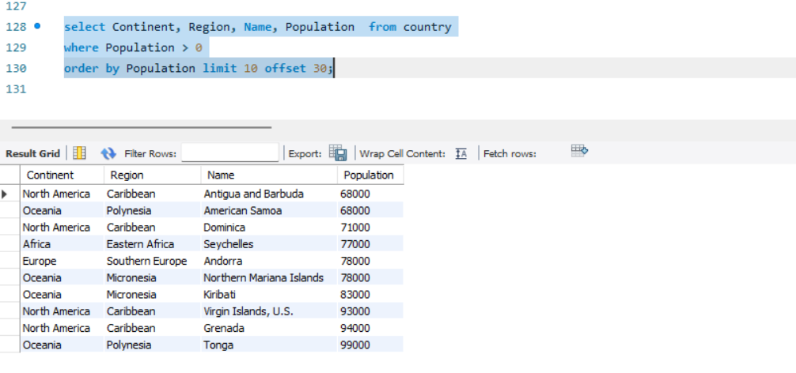

Additional Resources
- SQLBolt - Learn SQL - Introduction to SQL : Welcome to SQLBolt, a series of interactive lessons and exercises designed to help you quickly learn SQL right in your browser.
- MySQL Tutorial: Tutorial website.
- MySQL Basics Tutorial Series - YouTube: MySQL Basics Tutorial Series
- Hackerrank Challenges: How to use hackerrank challanges.odt
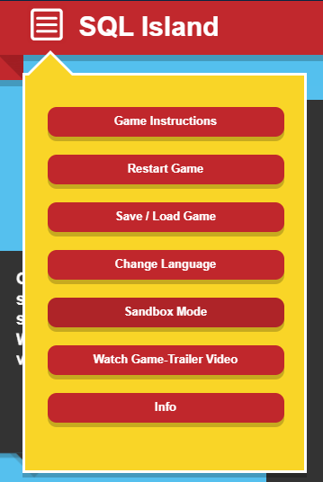
- Sakila DB Exercises:
  - Use this file to create the schema: create sakila db.sql
  - Access exercises here: sakila db exercises combined.sql
  - Follow each step to create your database and upload the exercise file. how to create sakila db and upload exercises.webm
- SQL Island: After the survived plane crash, you will be stuck on SQL Island for the time being. By making progress in the game, you will find a way to escape from this island.
Change Language to English.
- You can watch the video on how to open SQL file:How to create a schema in workbench.webm

Additional Information

Course Notes

It is recommended to take notes from the course, use the space below to do so, or use the revision guide shared with the class:

We have included a range of additional links to further resources and information that you may find useful, these can be found within your revision guide.

END OF WORKBOOK

Please check through your work thoroughly before submitting and update the table of contents if required.

Please hand in your workbook in MS Assignment page.

